syst 17796 Deliverable 1

design document template W2022

# Overview

## Project Background and Description

Each player must be dealt seven cards face-down. Place all of the remaining cards face-down to form a draw pile. Next, take the top card from the draw pile and place it face-up nearby to begin the discard pile. With both the draw and discard piles in place, you are ready to begin. Generally, the player to the dealer’s left will go first. However, you may also choose a player to begin or select the youngest player, oldest player, etc. This card game has a clockwise turn rotation. After the first player has finished their turn, the player to their left will begin theirs. When playing Uno, your goal will be to rid yourself of your cards as quickly and efficiently as possible. The only way to score points and ultimately win the game is by being the first player to run out of cards. To do this, you will need to play cards from your hand to match the number, color, or the action of the top card in the discard pile. You may also play a wild card to alter the color that is currently in play. if a Skip card is in play, your turn will be skipped. If a reverse card is in play, you will play your turn as usual, but then the game will begin to progress counter-clockwise instead of clockwise.

Describe the names and roles of each team member. Describe the technical scope of the project by talking about the interface and how you will know when the project is complete.

## High-Level Requirements

The new system will include the following:

* Ability for each player to register with the game - The game server and administrator will be responsible for registering the players on the website. For registering one may have the option of using phone number or email.

* Also, the players will have the option of choosing their username. Also, there will be a help section, which players can use to know the rules of game.
* Ability for the game to communicate a win or loss- the Uno game ends when all the cards of a player get finished. The winner will be declared by displaying a Big Uno banner along with the winner’s name in our game.
* Ability for players to know their status (score) at all times- the game server will show details like the number of cards left for each player, help menu.
* We might even allow the option of multi-player later on, where various users can compete against each other.

## Implementation Plan

1) First there would be a text file, where all teammates will specify the class, they have created and the parameters used, which class is it inheriting and its use. This would regularly be updated, so that each teammate can understand each other’s work and suggest changes if necessary. This would be used as our Javadoc. Team-mates can also create UML diagram to show the relation between various classes.

2) we will use a string to store the values of all cards.

3)A string that will contain wild card name, color and another string that will store the value of these wild cards.

4)A class to declare the winner’s name when all the cards get finished. This will need a string which would get updated after each turn and also may inherit the class which contains the values of the cards and wild cards

We will use Netbeans Ide for this project, as most of us are familiar with that ide, and would use the git for efficiency, where we will create branches of the base code and make parts of it according to our convenience.

## Models

* Create a Use Case diagram to illustrate the functional requirements of the system,
* Create a Domain Class Diagram to illustrate the key classes your system will have and their relationships

|  |  |  |
| --- | --- | --- |
| Thing/Noun | Type of Event | Activity |
| Register | External | The user registers to the server. |
| Connects and login | External | After registering the user connects to game server and login. |
| Start game | External | The user starts the game using start button. |
| Initialization by server | Internal | The server initializes the game and plays with the user. |
| Color request | Temporal | The user requests a color. |
| Draw card | Temporal | The user draws the next round of cards. |
| Mix card | Internal | The game server mixes the card randomly. |
| Declaring winner | Temporal | The winner is displayed by saying Uno at the end. |
| Get statistics | Temporal | The player wants to know the cards left and other statistics, so the administrator gets those stats from the server and this is viewed by player |

**Use case Diagram**

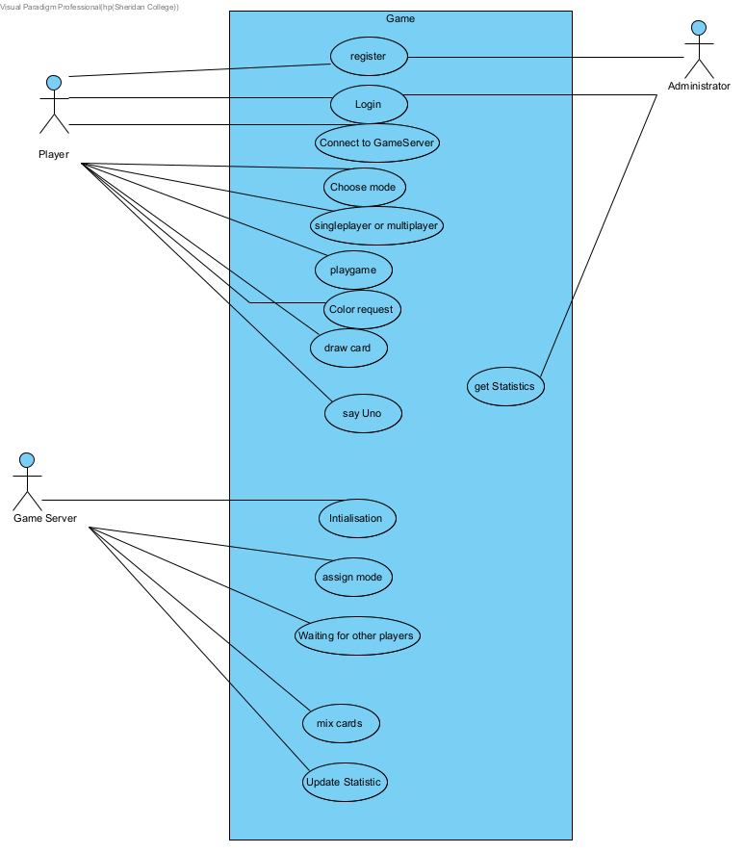

**Domain Class Diagram**

